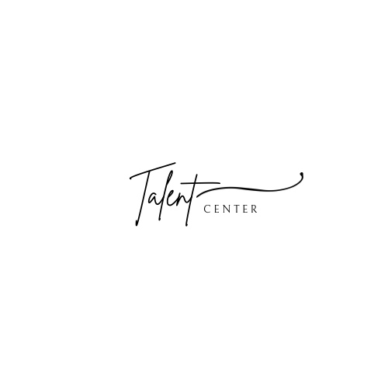
2024 International Performers Competition - St. Petersburg Arts Festival
"St. Petersburg, Russia"

* The competitions you will participate in
* Name of the Group / Performer
* Date of Birth
* Nationality, City
Current schoo / Current workplace
Location of the current school / Location of the current workplace
Teacher's name and surname
* Competition categories / Age categories / Competition nominations / Instrument or Major
* Piece Name / Composer Name
* Video link
* Email
* Please attach an image of your file below:
Photo for Winner Poster
Proof of age
Copy of participation fee and payment book

The completed application and methodological work must be sent to the address: arttalentcenter.info@gmail.com

